Chapter 9, Solution 83.

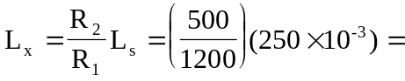 104.17 mH

